Multithreading and multiprocessing in PYTHON

Python is a multi and single threaded language at same time, and can utilize the multithreaded cpu to its advantage. Python’s asyncio provides a framework for writing single-threaded concurrent code using coroutines, event loops, and non-blocking I/O operations.
Q. Difference between thread and process?
sol -> Process is a program under execution whereas a thread is part of process…
We use pseudo multithreading to our advantage when trying to multithread and chain tasks….

https://www.youtube.com/watch?v=A_Z1lgZLSNc
Multithreading:- refers to the ability of the CPU to run multiple programs to run concurrently. And multiple threads share the data space with the main thread. Allows us to break a larger task in smaller subtasks and run these tasks simultaneously. Improves application speed and performance.
Multiprocessing: This refers to the ability of a system to run multiple unrelated processors in parallel fashion, where each processor can run one or more threads.
“Parallelism allows multiple tasks to execute at the same time, whereas concurrency allows multiple tasks to execute one at a time in an interleaving - concurrent manner”
- Due to Python Global Interpreter Lock (GIL), only one thread can be executed at a time. Therefore, multithreading only achieves concurrency and not parallelism for IO-bound processes. On the other hand, multiprocessing achieves parallelism.

Multithreading | Multiprocessing
Multithreading is useful for IO-bound processes, such as reading files from a network or database since each thread can run the IO-bound process concurrently. | Multiprocessing is useful for central processing unit (CPU)-bound processes, such as computationally heavy tasks since it will benefit from having multiple processors; similar to how multicore computers work faster than computers with a single core.
On cpu core level computationally tasks are managed by the cpu controlling algorithms to reduce load on the processor, leaving other processes idle or starved. | Using algorithms and logic using multiple CPU core at once and achieving true parallelism.
Using multithreading for CPU-bound processes might slow down performance due to competing resources that ensure only one thread can execute at a time, and overhead is incurred in dealing with multiple threads. | Using multiprocessing techniques we can better utilize the CPU and fastening the tasks.

Multithreading is useful for IO-bound processes, such as reading files from a network or database since each thread can run the IO-bound process concurrently.
Multiprocessing is useful for central processing unit (CPU)-bound processes, such as computationally heavy tasks since it will benefit from having multiple processors; similar to how multicore computers work faster than computers with a single core.
Imp resources
- https://builtin.com/data-science/multithreading-multiprocessing
- https://www.turing.com/kb/python-multiprocessing-vs-multithreading

Multithreading in Python using Threading module

- Create thread: Each thread is tagged to a Python function with its arguments.
- Start task execution.
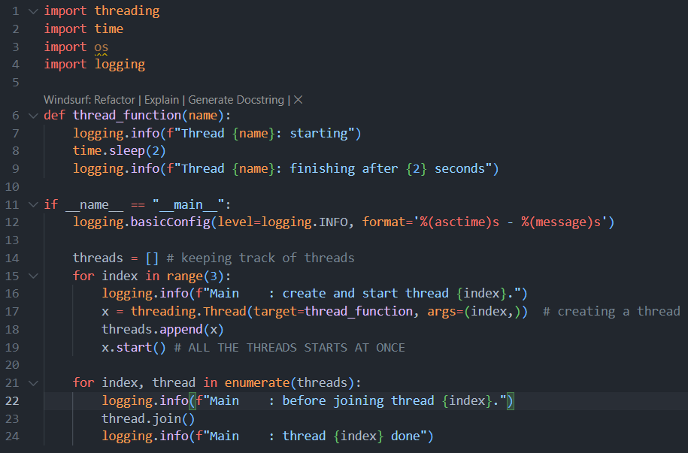
- Wait for the thread to complete execution: Useful to ensure completion or ‘checkpoints.’
Note
      - Create a thread worker function
      - Start the execution inside the for loop
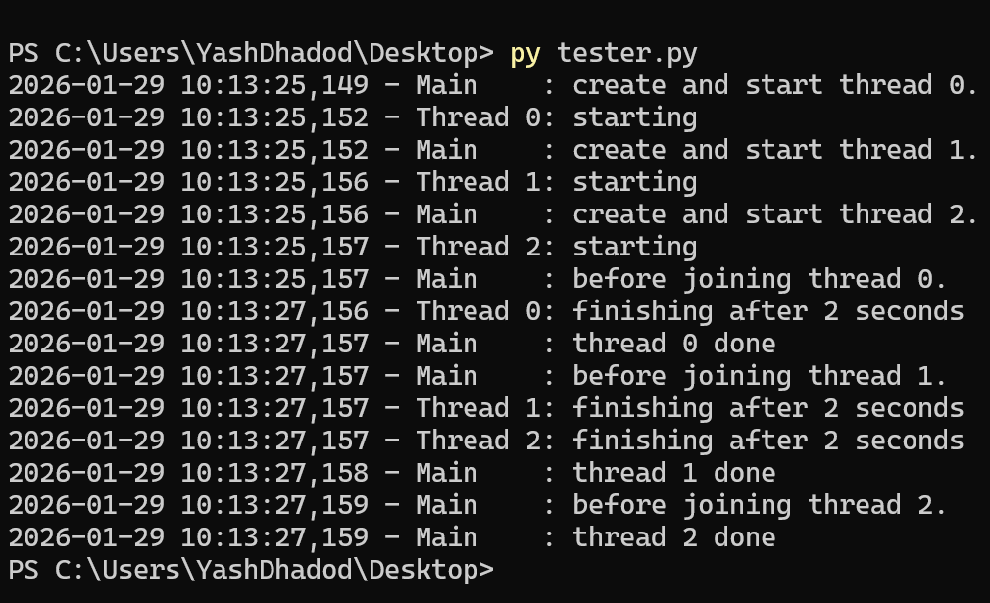
      - When one of the thread waits for the sleep other starts to run concurrently.

Daemon Threads -> Deamon process is a process that runs in the background.
If you walk through the output carefully, you’ll see all three threads getting started in the order you might expect, but in this case they finish in the opposite order! Multiple runs will produce different orderings. Look for the Thread x: finishing message to tell you when each thread is done.
Threads share global resources (variables, objects), but each thread has its own stack (local variables). Parent thread is main thread of the program and child thread or user created thread executes whatever you write into the worker function.

Thread Pool Executor :-> Allows you to run group of threads concurrently better way to run threads than the standard way ie. Using iterators.
In the import concurrent.futures =>
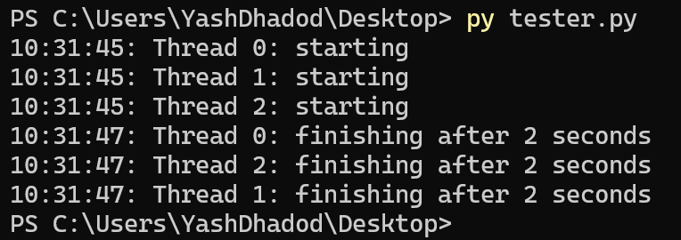
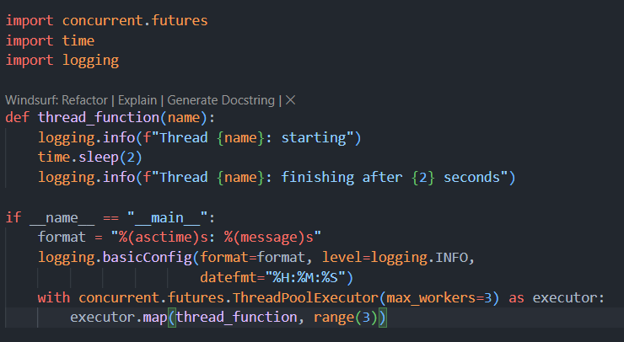

This create 3 threads and make them run concurrently. The code creates a ThreadPoolExecutor as a context manager, telling it how many worker threads it wants in the pool. It then uses .map() to step through an iterable of things, in your case range(3), passing each one to a thread in the pool.
The end of the with block causes the ThreadPoolExecutor to do a .join() on each of the threads in the pool. It is strongly recommended that you use ThreadPoolExecutor as a context manager when you can so that you never forget to .join() the threads.
Main thread stops the execution until out thread are completed. Using the .join t.join() blocks the calling thread (usually the main thread) until thread t finishes execution.
with lock: automatically calls:
- lock.acquire() at entry.
- lock.release() at exit.
With automatically calls the locks and releses the locks.
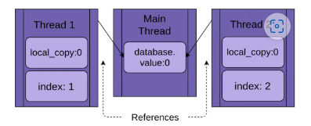
This kind of condition might create Race condition, where multiple threads fight for the resources and causes inconsistency I the data.

To tackle with this race condition we have multiple ways to avoid it :
            - Mutex locks : A Lock is an object that acts like a hall pass. Only one thread at a time can have the Lock. Any other thread that wants the Lock must wait until the owner of the Lock gives it up.
              - Two simple functions of this locks are lock.aquire() that provides the lock to the thread and make sure that the next thread does not have the access to the same resources.
              - Lock.release() make sure that the locks are available to acquire again and another thread can access the memory location.
- Fortunately, Python’s Lock will also operate as a context manager, so you can use it in a with statement, and it gets released automatically when the with block exits for any reason.
DeadLocks -> when the locks are not properly released other thread can starve of the resources and causing deadlocks.
An implementation bug where a Lock is not released properly
A design issue where a utility function needs to be called by functions that might or might not already have the Lock

Schedulers : 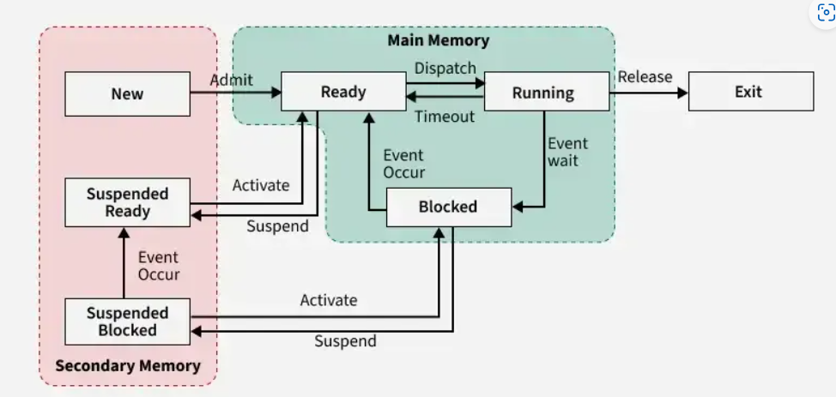
Process Schedulers in Operating System - GeeksforGeeks

Multiprocessing as a Python Function

Multiprocessing in python can be implemented using the import multiprocessing -> Python Multithreading vs. Multiprocessing Explained | Built In
Pool method allows users to define the number of workers and distribute all processes to available processors in a first-in-first-out scheduling, handling process scheduling automatically. The pool method is used to break a function into multiple small parts using map or starmap (line 19), running the same function with different input arguments. Whereas the process method is used to run different functions.
- Which is faster, multiprocessing or multithreading?
Multiprocessing is often faster for large, separate tasks, while multithreading can be faster for small, interconnected tasks.

# GIL (Global Interpreter Lock) : Guido van Rossum wrote this shit :
ensure that only one thread executes at a time. Mutex lock. Python support multithreading it is not a multithreaded language tho. This lock is necessary because Python’s memory management is not thread-safe. In simpler terms, the GIL makes sure that only one thread executes Python bytecode at a time, even in a multi-threaded application.
How does GC know what object to del is using the ref counter and for cyclic calls you just del have custome function to delete the shit.
For I/O-bound tasks, such as network or file I/O, the impact of the GIL is less pronounced because the GIL is released while waiting for I/O operations to complete, allowing other threads to run. However, for CPU-bound tasks, where threads are constantly executing Python bytecode, the GIL becomes a bottleneck.

Explanation:
- The issue: If two threads simultaneously modify the reference count, it can cause: corrupted memory, inconsistent object states and crashes
- Possible solution: CPython developers could lock every object or memory update, but that would make Python much slower.
- Final decision: Introduce one global lock - So CPython designers added a single interpreter-wide lock, the GIL, which guarantees:
- Thread-safe memory management
- Simplicity of implementation
- Fast performance for single-threaded programs
- Avoid Race condition in the OS , avoiding the starvation invalid modification of memory in the OS……

Therefore :
- Statement : Python is single threaded language that supports multithreading ->
  - Python itself is not strictly single-threaded—the language supports multithreading via the threading module, as you mentioned.
  - However, due to the Global Interpreter Lock (GIL) in CPython (the most common Python implementation), threads cannot execute Python bytecode in true parallel fashion. This means that multithreading in Python is often limited for CPU-bound tasks, but can be useful for I/O-bound tasks.
  - For true parallelism in CPU-bound tasks, Python developers often use the multiprocessing module, which creates separate processes rather than threads.

- Synchronous version: Judit plays one game at a time, never two at the same time, until the game is complete. Each game takes (55 + 5) * 30 == 1800 seconds, or 30 minutes. The entire exhibition takes 24 * 30 == 720 minutes, or 12 hours.
- Asynchronous version: Judit moves from table to table, making one move at each table. She leaves the table and lets the opponent make their next move during the wait time. One move on all 24 games takes Judit 24 * 5 == 120 seconds, or 2 minutes. The entire exhibition is now cut down to 120 * 30 == 3600 seconds, or just 1 hour.
- Multiprocessing vision : will be when there are multiple judit that are attending to the each player leadin to full Utilisation of the resources.

Sub interpreters :-> Subinterpreters in Python are a way to run multiple, isolated Python interpreters inside a single OS process. Think of them as “Python sandboxes” that share the same process but do not share most Python state. Single process ke andar multiple os interpreners run krne ki process ko kehete hai subinterpreners.
What is a sub interpreter?
A sub interpreter is an independent Python runtime with:-
- Its own global variables
- Its own modules and imports
- Its own execution state
But all subinterpreters:
- Run in the same process
- Share the same memory space at the OS level
- Historically share the Global Interpreter Lock (GIL)

https://realpython.com/async-io-python/
asyncio — Asynchronous I/O — Python 3.14.2 documentation
ASYNC IO: uses single threaded long time taking operations and optimizes them for its advantage. asyncio does not use multiple threads. It uses a single thread that switches tasks efficiently.
Greate for: API Calls, Network operations and Database operations.
SO, this is basically what we use for development and stuff. Be aware that async programming can get tricky when you venture a bit below the surface level. Python’s async model is built around concepts such as callbacks, coroutines, events, transports, protocols, and futures—even just the terminology can be intimidating.

Pre – required
- An event loop is a programming construct that allows a computer program to handle multiple tasks concurrently on a single thread. It operates by continuously checking for "events" (like user input, network requests, or timers) and dispatching them to the appropriate handlers when they are ready to be processed.
- Event loops decides which thread run next and controls overall flow of the programmic execution.
- Nothing run in the CPU executions unless its ready to run.
- Thread volunterly give control back to run other shit, rather than os forcing it onto the threads .
  - while True:
  - run task until it hits `await`
  - park it
  - run next ready task

- Coroutines and Coroutines functions
- which is an object that can suspend its execution and resume it later.
- Definitions such as -> async def -> just using the fucking async await in the running of programmes. Causes the concurrent execution to work in python,

- Import asyncio
- Make any function coroutine by async def func_name() :
- asyncio.gather() # used when wanting to run functions using async functionality
- asyncio.run(main (the entire line)) ->
- While one task awaits another tread is running in the backround.

Async -> introduces cororoutine to normal functions and its definition.
Await -> suspend the execution of the current function and return control back to event loop.

NEXT TOPIC IN THE MIX IS THE :-> >>>>

- asyncio.run() -> run the coroutine func given in the param .
- asyncio.create_task(func()) -> run the task immediately.
- asyncio.gather(task1(), task2(),task3()) -> run multiple coros at once.

Common Async I/O Programming Patterns in https://realpython.com/async-io-python/

async def foo():
print("start")
await bar()
print("end")
c = foo() ❌ foo() does not run the function
✅ it returns a coroutine object

When the coro is created :
• frame is kept alive
• nothing is recomputed
• memory stays allocated

Cooperative Multitasking :->
• Voluntary Yielding:
- A process must cooperate and explicitly give up the CPU.
- If a process never yields, other processes get starved.
• No Preemption:
- The OS cannot forcefully interrupt a running process.
- This is different from preemptive multitasking, where the OS can interrupt processes.
• Simplicity:
- Easier to implement because there’s no need for complex context-switching logic.
• Drawback:
- One misbehaving or infinite-loop process can freeze the entire system.

Using threading module : Question : 1114. Print in Order
Import threading
Event() -> for interaction between multiple threads we can use the event

Has two main function :->
  - .set() -> sets a internal variable as true
  - .clear() – sets internal variable as False
  - .wait() -> wait for previous thread to .set() variable. (is blocked)
import threading

class Foo:
def __init__(self):
# self.var = 0

# or using the threadign events
self.first_comp = threading.Event()
self.second_comp = threading.Event()

def first(self, printFirst: 'Callable[[], None]') -> None:
printFirst()
# when this thread returns
# self.var += 1

# set the thread event positive
self.first_comp.set()

def second(self, printSecond: 'Callable[[], None]') -> None:
# while True : # makes sure that the thread starts but does not executes the printSec
# if self.var == 1:
# printSecond()
# self.var += 1
# break
self.first_comp.wait() # wait for the first event to be completed
printSecond()
self.second_comp.set()

def third(self, printThird: 'Callable[[], None]') -> None:
# while True :
# if self.var == 2 :
# printThird()
# self.var += 1
# break

self.second_comp.wait() # wait for the first event to be completed
printThird()

